

**Software Engineering**

**Lab 2 (ParkingSlot)**

Submitted by:

Tan Jia Wei U1821234H

Wong Chun Foong U1822939L

Goh Jun Le U1820246G

An Zhi Andrew Cai N1902005C

Emmi Mannonen N1902011B

Nurul Sabrina Binte Mohammed Riduwan U1822849A

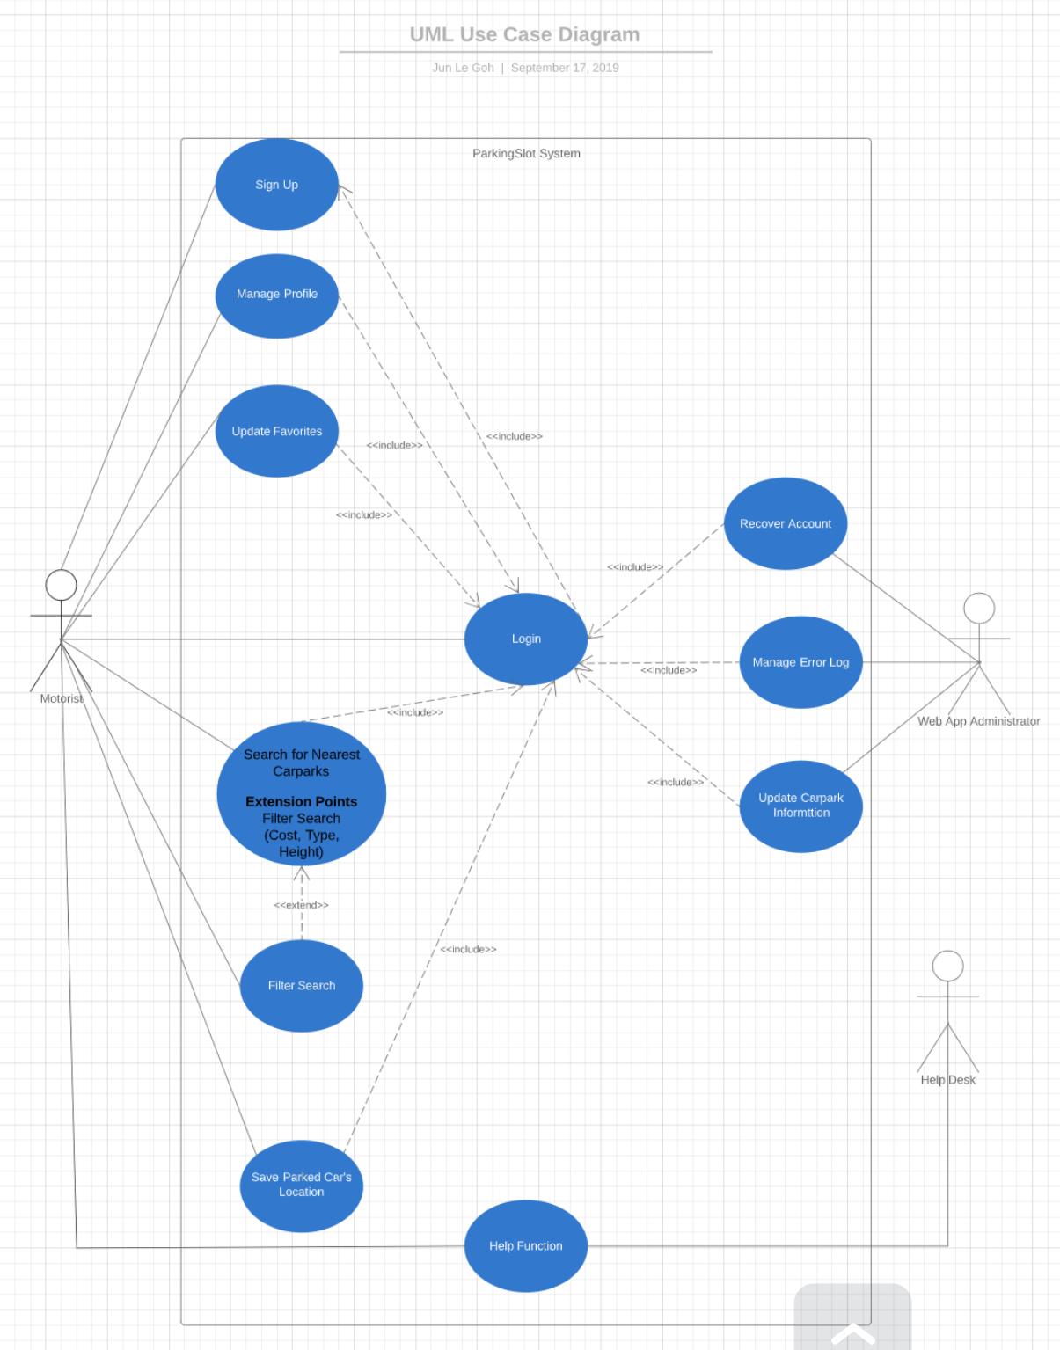

**Use Case Description**

|  |  |  |  |
| --- | --- | --- | --- |
| Use Case ID: | 001 | | |
| Use Case Name: | **Sign Up** | | |
| Created By: | Chun Foong | Last Updated By: | Jun Le |
| Date Created: | 21/8/2019 | Date Last Updated: | 12/9/2019 |

|  |  |
| --- | --- |
| Actor: | Motorist |
| Description: | Motorist registers account |
| Preconditions: | Motorist does not have the account |
| Postconditions: | Motorist successfully creates account |
| Priority: | High |
| Frequency of Use: | Motorist will only do this once |
| Flow of Events: | 1. Motorist key in Username, Email, Password, Phone Number 2. System verifies Motorist details 3. If valid, Motorist able to proceed to use the application |
| Alternative Flows: | Motorist application invalid if invalid email address:   The application will be rejected |
| Exceptions: | N. A |
| Includes: | N. A |
| Special Requirements: | N. A |
| Assumptions: | N. A |
| Notes and Issues: | N. A |

|  |  |  |  |
| --- | --- | --- | --- |
| Use Case ID: | 002 | | |
| Use Case Name: | **Manage Profile** | | |
| Created By: | Jia Wei | Last Updated By: | Jun Le |
| Date Created: | 21/8/2019 | Date Last Updated: | 12/9/2019 |

|  |  |
| --- | --- |
| Actor: | Motorist |
| Description: | Motorist is able to update their information or delete their account |
| Preconditions: | Motorist have logged in the application |
| Postconditions: | Motorist have updated their information or deleted their account |
| Priority: | Medium |
| Frequency of Use: | Motorist will use this when they wish to change their profile settings |
| Flow of Events: | 1. Motorist logged into the application 2. Click on Manage profile 3. Once Motorist is in the Manage profile:    1. Motorist able to update their information    2. Motorist able to delete their account |
| Alternative Flows: | N.A. |
| Exceptions: | N.A |
| Includes: | Logged into the application |
| Special Requirements: | N. A |
| Assumptions: | N. A |
| Notes and Issues: | N. A |

|  |  |  |  |
| --- | --- | --- | --- |
| Use Case ID: | 003 | | |
| Use Case Name: | **Update Favorites** | | |
| Created By: | Andrew | Last Updated By: | Jun Le |
| Date Created: | 21/8/2019 | Date Last Updated: | 12/9/2019 |

|  |  |
| --- | --- |
| Actor: | Motorist |
| Description: | User can add or delete a carpark on his favorites’ list |
| Preconditions: | 1. The motorist must be logged in to the application |
| Postconditions: | 1. The motorist must be able to save or delete  his desired carpark into his favorites |
| Priority: | Medium |
| Frequency of Use: | Often |
| Flow of Events: | 1. The motorist logs into the application 2. The motorist clicks on ‘Update Favorites’ 3. The motorist chooses to add carpark or delete carpark by entering Carpark ID or Carpark Address |
| Alternative Flows: | If the carpark ID or carpark addresss is not found, display a message “Please find another carpark. ID or Address is unable to be saved  into favorites.” |
| Exceptions: | N.A. |
| Includes: | Login |
| Special Requirements: | N.A. |
| Assumptions: | N.A. |
| Notes and Issues: | N.A. |

|  |  |  |  |
| --- | --- | --- | --- |
| Use Case ID: | 004 | | |
| Use Case Name: | **Login** | | |
| Created By: | Sabrina | Last Updated By: | Jun Le |
| Date Created: | 21/8/2019 | Date Last Updated: | 12/9/2019 |

|  |  |
| --- | --- |
| Actor: | Motorist |
| Description: | Motorist logs into the application |
| Preconditions: | Motorist must have signed up for an account |
| Postconditions: | Motorist stays logged in the application |
| Priority: | High |
| Frequency of Use: | Whenever motorist wants to use the application, he has to login |
| Flow of Events: | 1. Motorist signs up for an account 2. Motorist enters username 3. Motorist enters password 4. Motorist successfully logs in |
| Alternative Flows: | If the motorist enters wrong username or  password, display message “Wrong username/password entered.” |
| Exceptions: | If the motorist enters wrong username or  password 5 or more times in a row, display message “Account is locked out for an hour. Please try again later.” |
| Includes: | Sign Up |
| Special Requirements: | N. A |
| Assumptions: | N.A. |
| Notes and Issues: | N. A |

|  |  |  |  |
| --- | --- | --- | --- |
| Use Case ID: | 005 | | |
| Use Case Name: | **Search For Nearest Carparks** | | |
| Created By: | Jun Le | Last Updated By: | Jun Le |
| Date Created: | 21/8/2019 | Date Last Updated: | 12/9/2019 |

|  |  |
| --- | --- |
| Actor: | Motorist |
| Description: | The motorist searches for nearest carparks, and a list of up to 10 nearest carparks is returned |
| Preconditions: | 1. The motorist have logged into the application 2. The motorist have switched on GPS on his phone 3. The motorist must enter his vehicle type 4. The motorist must enter his intended parking duration |
| Postconditions: | 1. The motorist receives a list of up to 10 nearest carparks on his phone or 2. The motorist receives a message that no carparks are found within the parameter |
| Priority: | High |
| Frequency of Use: | Often |
| Flow of Events: | 1. The motorist logs into the application 2. The motorist enters his vehicle type and parking duration 3. The motorist can choose his filter options by Carpark Rates, Carpark Type, Carpark Height 4. The motorist can choose to use current location or manually select location 5. The motorist presses “Search For Nearest Carparks” button 6. The motorist views a list of up to 10 nearest carparks within motorist’s parameters |
| Alternative Flows: | If the motorist’s filter options are invalid  The system displays the message “No carparks found. Please refine your filter options.” |
| Exceptions: | N. A |
| Includes: | Login |
| Special Requirements: | N. A |
| Assumptions: | N. A |
| Notes and Issues: | N. A |

|  |  |  |  |
| --- | --- | --- | --- |
| Use Case ID: | 006 | | |
| Use Case Name: | **Filter Search** | | |
| Created By: | Emmi | Last Updated By: | Jun Le |
| Date Created: | 21/8/2019 | Date Last Updated: | 12/9/2019 |

|  |  |
| --- | --- |
| Actor: | Motorist |
| Description: | The motorist filters his search by parameters like Carpark Rates, Carpark Type and Carpark Height |
| Preconditions: | The motorist needs to be logged in |
| Postconditions: | The motorist must be able to make a search with the carpark height parameters specified |
| Priority: | High |
| Frequency of Use: | Often |
| Flow of Events: | 1. The motorist logs into the application 2. The motorist enters his vehicle type and parking duration 3. The motorist can choose his filter options by Carpark Rates, Carpark Type and Carpark Height 4. The motorist makes a search 5. The motorist must be able to view the results with the specified parking parameters applied |
| Alternative Flows: | If there are no results found:  The system displays the message “No carparks found. Please refine your filter options.” |
| Exceptions: | N. A |
| Includes: | N. A |
| Special Requirements: | N. A |
| Assumptions: | N. A |
| Notes and Issues: | N. A |

|  |  |  |  |
| --- | --- | --- | --- |
| Use Case ID: | 007 | | |
| Use Case Name: | **Save Parked Car’s Location** | | |
| Created By: | Jun Le | Last Updated By: | Jun Le |
| Date Created: | 21/8/2019 | Date Last Updated: | 12/9/2019 |

|  |  |
| --- | --- |
| Actor: | Motorist |
| Description: | The motorist saves his parked car’s location as a reminder for himself |
| Preconditions: | The motorist must be logged in to the application |
| Postconditions: | The motorist must be able to successfully save his parked car’s location |
| Priority: | Medium |
| Frequency of Use: | The motorist could choose to use this after he parks his car |
| Flow of Events: | 1. The motorist logs into the application 2. The motorist saves his parked car’s location |
| Alternative Flows: | N. A |
| Exceptions: | N. A |
| Includes: | Login |
| Special Requirements: | N. A |
| Assumptions: | N. A |
| Notes and Issues: |  |

|  |  |  |  |
| --- | --- | --- | --- |
| Use Case ID: | 008 | | |
| Use Case Name: | **Help Function** | | |
| Created By: | Chun Foong | Last Updated By: | Jun Le |
| Date Created: | 21/8/2019 | Date Last Updated: | 12/9/2019 |

|  |  |
| --- | --- |
| Actor: | Motorist, Help Desk |
| Description: | Motorist can seek help when they face any problems. |
| Preconditions: | NA |
| Postconditions: | Motorist must be able to reach the help desk for help |
| Priority: | Low |
| Frequency of Use: | NA |
| Flow of Events: | 1. Motorist face problems 2. Motorist use the help function 3. System received help request and provide necessary help to the Motorist |
| Alternative Flows: | NA |
| Exceptions: | NA |
| Includes: | NA |
| Special Requirements: | NA |
| Assumptions: | N.A. |
| Notes and Issues: | NA |

|  |  |  |  |
| --- | --- | --- | --- |
| Use Case ID: | 009 | | |
| Use Case Name: | **Recover Account** | | |
| Created By: | Jia Wei | Last Updated By: | Jun Le |
| Date Created: | 1/9/2019 | Date Last Updated: | 12/9/2019 |

|  |  |
| --- | --- |
| Actor: | Web App Administrator |
| Description: | The administrator can recover deleted user accounts |
| Preconditions: | The web app administrator must be logged in |
| Postconditions: | Administrator must be able to successfully recover deleted user accounts |
| Priority: | High |
| Frequency of Use: | Low |
| Flow of Events: | 1. The web app administrator logs into the application 2. The web app administrator sees a list of requests for recovered accounts 3. The web app administrator approves the requests for recovered accounts |
| Alternative Flows: | NA |
| Exceptions: | NA |
| Includes: | Login |
| Special Requirements: | NA |
| Assumptions: | N.A. |
| Notes and Issues: | NA |

|  |  |  |  |
| --- | --- | --- | --- |
| Use Case ID: | 010 | | |
| Use Case Name: | **Manage Error Log** | | |
| Created By: | Andrew | Last Updated By: | Jun Le |
| Date Created: | 1/9/2019 | Date Last Updated: | 12/9/2019 |

|  |  |
| --- | --- |
| Actor: | Web App Administrator |
| Description: | The administrator can view or delete the errors in the log |
| Preconditions: | The web app administrator must be logged in |
| Postconditions: | Administrator must be able to successfully  view or delete the errors in the log |
| Priority: | High |
| Frequency of Use: | High |
| Flow of Events: | 1. The web app administrator logs into the application 2. The web app administrator views the error log 3. The web app administrator works on debugging the errors 4. The web app administrator deletes the errors after he has solved the errors |
| Alternative Flows: | NA |
| Exceptions: | NA |
| Includes: | Login |
| Special Requirements: | NA |
| Assumptions: | N.A. |
| Notes and Issues: | NA |

|  |  |  |  |
| --- | --- | --- | --- |
| Use Case ID: | 011 | | |
| Use Case Name: | **Update Carpark Information** | | |
| Created By: | Sabrina | Last Updated By: | Jun Le |
| Date Created: | 1/9/2019 | Date Last Updated: | 12/9/2019 |

|  |  |
| --- | --- |
| Actor: | Web App Administrator |
| Description: | The administrator can create or update carpark information in the database |
| Preconditions: | The web app administrator must be logged in |
| Postconditions: | The information created or updated must be succesfully saved in the database |
| Priority: | High |
| Frequency of Use: | High |
| Flow of Events: | 1. The web app administrator logs into the application 2. The web app administrator can choose to create or update carpark information if information has changed in real-time 3. Data changed or created must be saved in the database |
| Alternative Flows: | NA |
| Exceptions: | NA |
| Includes: | Login |
| Special Requirements: | NA |
| Assumptions: | N.A. |
| Notes and Issues: | NA |